Code Injection
# Source: Chatgpt (GPT-5-Mini) at [1/20/2026]
Code injection is a type of cyberattack where an attacker inserts (or "injects") malicious code into a program or system, exploiting a security vulnerability to make the system run unauthorized commands or alter behavior.
The goal is often to manipulate the system's behavior, steal data, or take control.
It happens when an application improperly handles user input, allowing attackers to "inject" harmful code into the system.

🧨 Common Types of Code Injection
# Source: Chatgpt (GPT-5-Mini) at [1/20/2026]

Type | Injected Into | Purpose | Example
SQL Injection | Database queries | Read/modify/delete data in the database | '; DROP TABLE users; --
Command Injection | Operating system shell | Run system-level commands | ; rm -rf /
XSS (Cross-Site Scripting) | Browser | Run JavaScript in users' browsers | <script>alert('XSS')</script>
HTML Injection | Web page content | Modify layout or content; may lead to XSS | <h1>Hacked!</h1>
XML Injection | XML data sent to parsers or web services | Alter XML structure or content to change app logic or cause errors | Input inserts additional XML tags or breaks XML format to modify processing
XPath Injection | XPath queries in XML documents | Manipulate or bypass authentication by altering XML query logic | Input: ' or '1'='1 used in XPath query to always return true
LDAP Injection | LDAP queries | Bypass authentication or access unauthorized data | *)(userPassword=*)

How SQL Injection Works (example):
# Source: Chatgpt (GPT-5-Mini) at [1/20/2026]
If a website’s login form directly inserts user input into a database query without proper validation:
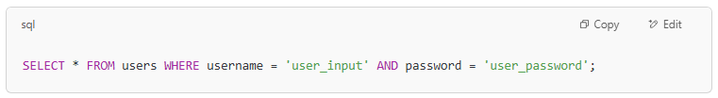
SELECT * FROM users WHERE username = 'user_input' AND password = 'user_password';

An attacker could enter something like:
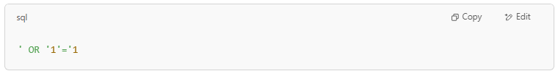
' OR '1'='1

making the query:
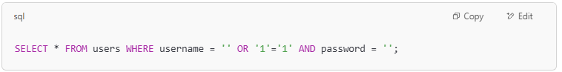
SELECT * FROM users WHERE username = '' OR '1'='1' AND password = '';
Since '1'='1' is always true, this could trick the system into granting access without a valid password.

🔒 How to Prevent Code Injection
# Source: Chatgpt (GPT-5-Mini) at [1/20/2026]
Validate and Sanitize Input
– Only allow expected characters, reject harmful ones.
Use Parameterized Queries / Prepared Statements
– For SQL and other query languages.
Escape Output
– When inserting user input into HTML, JavaScript, or shell commands.
Use Security Libraries
– Like ORM frameworks, input validation libraries, or template engines.
Least Privilege Principle
– Limit what the application and database can do (e.g., no root access).

✅ Summary
# Source: Chatgpt (GPT-5-Mini) at [1/20/2026]
- Code injection allows attackers to insert malicious code into your app.
- It can lead to data theft, system compromise, or site defacement.
- Prevention requires secure coding practices, input validation, and safe APIs.

